Sustainability Reporting In Unbalanced Global Economy
This paper examines the role of the sustainability reporting and its features in European countries and in Russia. Using the open sources of the Global Reporting Initiative (GRI) the information about the indicators of sustainability report is collected. In particular, the influence on financial indicators of companies by indirect factors such as working condition is measured. Sustainability reporting creates real opportunity for unbalanced economy to diversify risks of companies’ performance, reduce costs and improve efficiency.
Unbalanced global economy is influenced by such factors as forced and compulsory labor, internal frauds, wasting of energy resources and discrimination of particular groups. Sustainability reporting is a recent development that promotes the principles of fair trading, investing in new technologies and scientific researches.
Pressures of increasing population, overgrazing, overcultivation have a strong influence on the future performance of particular companies. A life cycle of a company that cuts down trees and doesn’t care about reforestation can’t be considered as long-term and perspective. Eventually, fertile topsoil may be entirely destroyed, leaving only dust, bare rock and no perspectives for doing business and money in the future.
Company should be aware of any possible risks on financial markets. In this case financial reporting provides the company and investors with full information about the rate of liquidity, relations between liabilities and assets and other financial indicators. Financial reporting includes Balance sheet, Income statement, Profits & Losses statement and Cash flow statement. These statements have been proved to be reliable for a really long time until the economy became global and other factors appear to have great influence on the profits and losses of a particular organization.
Business is trying to create strong reputation in order to make investors confident about the future performance and its role in financial markets. Share prices are volatile so that their price could stay at the level of «junk bonds» because of any reported allegation in news according to fundamental analysis.
Sustainability report is an obligatory report for companies in Europe and America that provides potential investors and other users with data and information about performance of particular business. Companies publish a sustainability report that deals with economic, governance, environmental and social impacts caused by its everyday activities. The organization values and governance model are presented in sustainability report. The recent researches demonstrate that companies presented systematic sustainable reporting could lessen the impact of crisis in 2008. The high quality of sustainable report made investors more confident about the future perspectives of a particular firm. A.T. Kearny examined profits and losses of a diversity amount of companies and came to the conclusion that sustainability reporting helps firms to increase their capitalization up to $650 million.
This year non-financial statements have been presented by prominent companies in different areas. BP (energy sector), Morgan Stanley (financial sector), Apple and IBM (computer science technologies) have released a fully disclosure of impact of their activity on social and environmental area. International companies are as conscious about their reputation in a business society as small firms are. It is commonly known that Tabacco is doing a huge harm to our health and as a result of the obligatory sustainability reporting the biggest Tobacco company British American Tobacco (BAT) released a non-financial statement where the new technologies in cigarette manufacturing are presented. Obligatory sustainability reporting made BAT renovate cigarette manufacturing process and create a technology that is twice as less harmful as it was previously. The number of non-financial statements increases from 2149 in 2010 to 4155 statements in 2013 year.
The main reason why there are increasing numbers of companies reporting non-financial statement is possibility to measure risks of their performance. Social, governance, economic and environmental operations are presented in non-financial statements. These four key areas play a huge role in building strong connections between a company and investors. It is a regular monitoring of sustainability performance that makes investors confident about the future of a particular firm. The global economy combines long term profitability based on ethical behavior and social justice that is why sustainability reporting is a vital resource for managing change inside the company performance and structure.
There are no strict rules and requirements about how the sustainability reporting should be produced although Global Reporting Initiative (GRI) set a number of indicators that should be disclosed. Global Reporting Initiative was founded in 1999 and since then it has been developing and promoting the reporting system that enables organizations to measure risk of their everyday performance. GRI services don’t pass and verify the quality of the disclosures although they help company with preparing non-financial reports by releasing official guidelines. The step-by-step instruction is available on the on-line resource. The requirements to the high quality sustainable statement are presented on the official website. There main indicators could be found.
GRI insists on organization revealing the information about training and education costs, presence of freedom of association inside the company and equal opportunities for women and men, absence of child labor and other essential indirect economic factors.
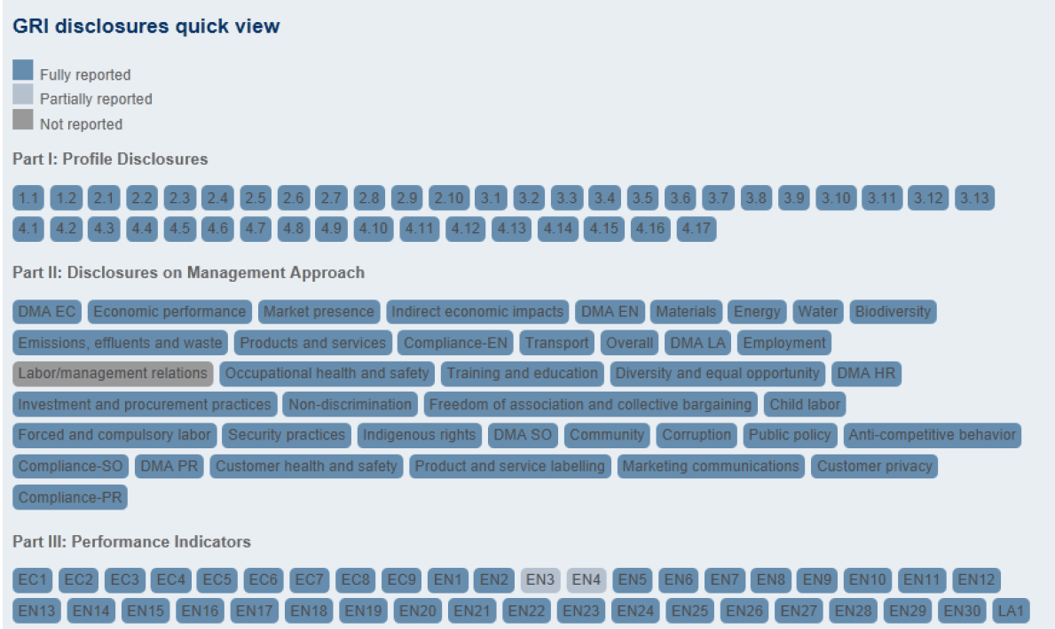
Pic 1 GRI disclosures quick view
The organization is advised to reveal the information about raw materials that are used in manufacturing goods. This information demonstrates investors how the company is anxious about environmental system and if there is an opportunity for any government to raise taxes because of gas emissions and water polluting. There is a strong connection between environmental performance and Earnings Before Interest, Taxes, Depreciation, and Amortization (EBITDA) which is the main reason why European investors examine under scrutiny non-financial statements.
Concealed indicators can immediately reveal weaknesses of a particular organization and investor has a chance to anticipate future profits and losses. According to official GRI statistic the indicator «Equal remuneration for women and men» is being concealed in 17% and the other indicator «Child labor» wasn’t disclosed in 15% of all disclosures.
Analyzing the background of companies that didn’t disclose the «Child labor» indicator shows us that indirect economic impact has huge influence on the goodwill of companies and their revenue. Using child labor isn’t allowed in the world although several companies hire children at the age of 12 or even 10 years old. A huge fine system is created by the government. In some countries there is also a possibility for a law to prohibit the performance of such organizations. Financial statements don’t reveal the information about employees while non-financial statement does. It is very important for investor to be aware of the fact that the performance of the organization is legal. In 2013 Apple refused to do business with Chinese company «Guangdong Real Faith Pingzhou Electronics» that had been using Child labor. The company was fined a huge amount of money. In 2014 Samsung ceased to cooperate with Chinese company «Dongguan Shinyang Electronics» that had employed children to do a hard job. Investors lost a huge amount of money because of the public scandal and the absence of clients for those Chinese companies. The necessity to reveal full information about employees and education, health and safety costs make companies improve the conditions for workers in general.
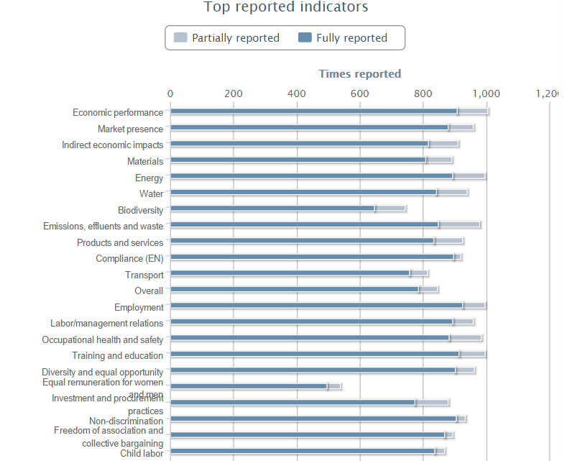
Pic 2. Top reported indicators
According to GRI official statistic firms don’t report the data about the amount of energy and water used in the manufacturing process and it arises a question: «Does the company have new technologies to reduce raw material costs or it wastes the resources and invested money?» The answer should be given. Firms don’t want to create a reputation of a company that doesn’t consern the future of nature so they renovate their technologies. Promoting sustainable reporting helps investors to anticipate future cash flows.
There are internal and external benefits of sustainable reporting for companies. Increased understanding of risks and opportunities, improving efficiency, reducing costs are the key internal benefits for business. Assessing sustainability with respect to performance standards and laws has created a strong base for making contacts with private and government sector. External benefits of sustainability reporting include improving reputation and brand loyalty, increasing the price of intangible assets namely Goodwill and forecast a possible relation between profits and losses of a company.
Sustainability reporting in Russia is not compulsory. Companies don’t worry about environmental system and social rights. This policy undervalues possible risks and makes foreign investors unconfident about their savings. Absence of information about government relations is one of crucial reasons why investors are not interested in building long-term connections with Russian companies.
In 2012 the Directive about obligatory sustainable reporting was released by the President V.Putin. It states that companies are obliged to report non-financial statements in 2016. The Directive also states to create a governance structure with a respect to Global Reporting Initiative. This structure should create special requirements that comply with Russian features. In future Russian non-financial system will integrate with Global Reporting Initiative so that the amount of foreign investments increases.
The economy is unbalanced because of different factors. The key problem is meaningless and unconscious attitude to environmental, social, governance and economic system. Sustainability reporting makes business reveal the information about the influence on these factors. Because of the willingness to have a strong reputation companies are keen on improving their system. Sustainability reporting can help the whole world to reduce destructive and ruinous impact on environmental and social sphere.
Resources:
- Claremont McKenna College, 2010.
- https://www.globalreporting.org/SiteCollectionDocuments/2014/GRIs-new-governance-structure.pdf
- https://www.globalreporting.org/SiteCollectionDocuments/2014/Summary-Report-Public-Comment-Process.pdf
- http://database.globalreporting.org/benchmark
- https://www.globalreporting.org/resourcelibrary/GRI-Data-Legend-Sustainability-Disclosure-Database-Profiling.pdf
- http://database.globalreporting.org/benchmark

